<Totally Unimodular Matrices (TU Matrices)>

**Definition:** A matrix *A* is *totally unimodular (TU)* if every square submatrix of *A* has determinant +1, -1 or 0.

e.g. $\left(\begin{matrix}1 & -1 \\ 1 & 1\end{matrix}\right)$, $\left(\begin{matrix}1 & -1 \\ 0 & 1\end{matrix}\right)$

**Proposition 1.** A matrix *A* is TU iff

1. $A^{T}$ is TU iff
2. The augmented matrix (A I) is TU.

**Proposition 2. (충분조건 for TU)**

$a_{ij}∈\{+1, -1,0\} ∀i,j$

1. Each column contains at most two nonzero coefficients ($\sum_{i=1}^{m}{|a_{ij}|}≤2$)
2. There exists a partition ($M_{1}, M_{2}$) of the set M of rows such that  
   each column j containing two nonzero coefficients satisfies $\sum_{i∈M_{1}}{a_{ij}}-\sum_{i∈M_{2}}{a_{ij}}=0$.

($M_{1}∪M_{2}=M, M_{1}∩M_{2}≠∅$ and one of them can be empty.)

Suppose that there is a linear system such that $Ax≤b, x≥0$ where $A∈Z^{m×n}$ (integral matrix) and $b∈Z^{m}.$ Then, we have the following theorem.

**Hoffman-Kruskal’s *Theorem:***

*The polyhedron $\{x:Ax≤b, x≥0\}$ is integral (⇔All the vertices of the feasible region are integral) for every $b∈Z^{m}$ iff A is totally unimodular (TU).*

* The proof refers to pp.132 in “**Integer Programming” written by Conforti et. al.**(Check: Cramer’s rule, vertex=basic feasible solution=extreme point, the properties of TU)

**Therefore, if the matrix in a linear system is TU and the vector on the right-handed side in the system is integral, then we always have the optimal solution which is integral only by applying the algorithms for solving LP!**

**It is very important to figure out TU structure in the system which allows us to easily or partially solve the IP problem.**

**Examples>**

1. Transportation Problem: M (|M|=3): suppliers, N: demands (|N|=2)

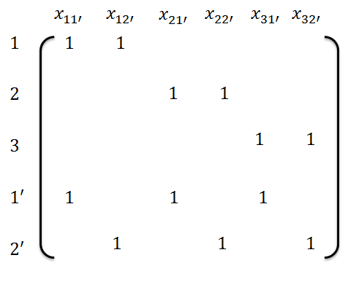

1. Network Problem (incidence matrix): Minimum Cost Network Flows

